**Package**

* Package is a folder that contains group of related classes and interface.

**Advantages**

* Accessing is Faster
* It resolves naming conflict

**Types of packages**

* Predefined Package
  + The packages which are created by the vendor is called predefined package.
* User Defined Package
  + The packages which are created by the programmer is called user defined package.

**Creation of User Defined Package**

* Create a folder with any name (e.g. pack). The package name and folder name must be same.
* Write a program and save it inside package.

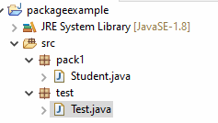

**Student.java**

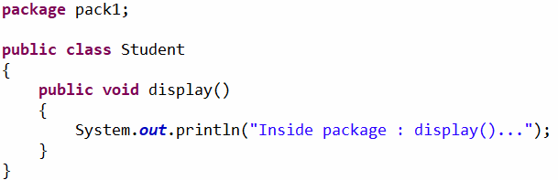

**How to access user defined package**

**Test.java**

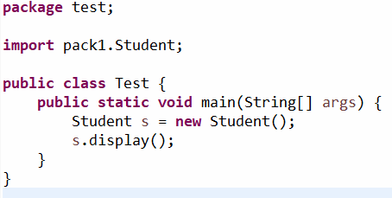

**Note**

* Inside the source file it is possible to declare only one package statement and that statement must be first statement of the source file.

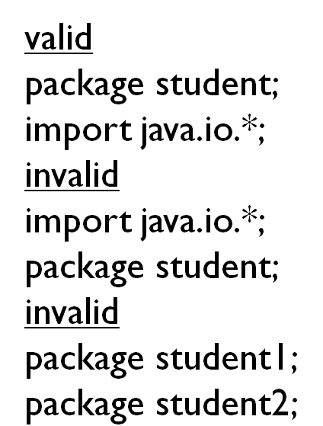

**Sub Package**

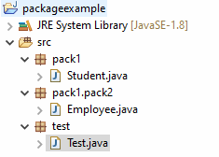

**Employee.java**

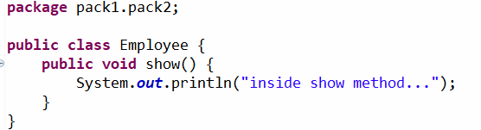

**Test.java**

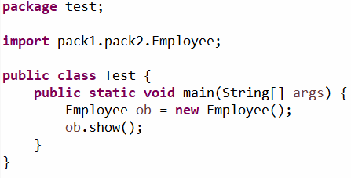

**Access Modifier**

* Access modifier decides the visibility of class members.
* Java support following access modifier for visibility:
  + Private
  + Default
  + Protected
  + Public

**Summary of access modifier**

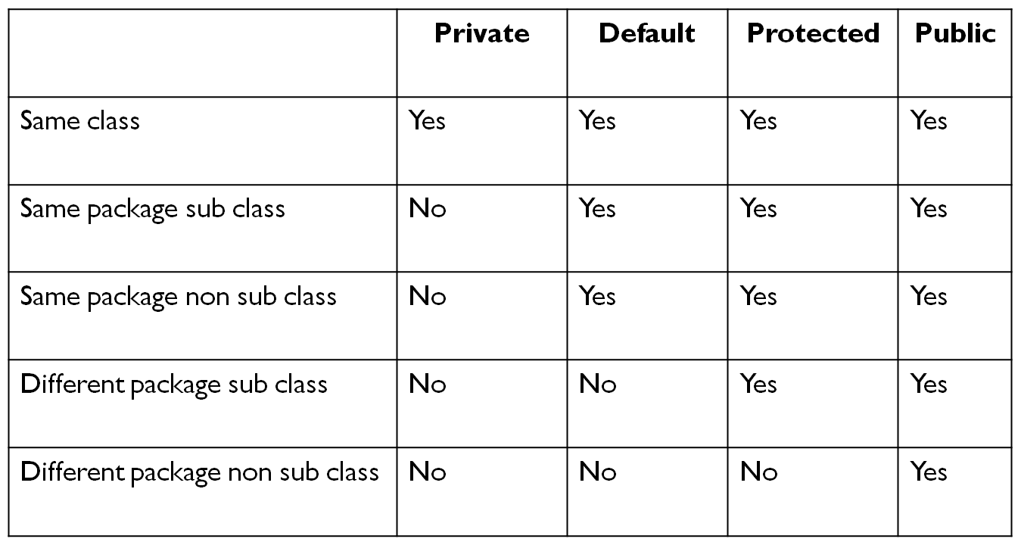

**Example#1**

**package** test;

**class** Demo {

**private** **int** a = 10;

**int** b = 20;

**protected** **int** c = 30;

**public** **int** d = 40;

**void** show() {

System.***out***.println("a = " + a);

System.***out***.println("b = " + b);

System.***out***.println("c = " + c);

System.***out***.println("d = " + d);

}

}

**public** **class** Test {

**public** **static** **void** main(String[] args) {

Demo ob = **new** Demo();

ob.show();

}

}

**Example#2**

**package** test;

**class** Demo {

**private** **int** a = 10;

**int** b = 20;

**protected** **int** c = 30;

**public** **int** d = 40;

}

**class** Best **extends** Demo{

**void** show() {

//System.out.println("a = " + a);

System.***out***.println("b = " + b);

System.***out***.println("c = " + c);

System.***out***.println("d = " + d);

}

}

**public** **class** Test {

**public** **static** **void** main(String[] args) {

Best ob = **new** Best();

ob.show();

}

}

**Example#3**

**package** test;

**class** Demo {

**private** **int** a = 10;

**int** b = 20;

**protected** **int** c = 30;

**public** **int** d = 40;

}

**class** Best{

**void** show() {

Demo ob = **new** Demo();

//System.out.println("a = " + ob.a);

System.***out***.println("b = " + ob.b);

System.***out***.println("c = " + ob.c);

System.***out***.println("d = " + ob.d);

}

}

**public** **class** Test {

**public** **static** **void** main(String[] args) {

Best ob = **new** Best();

ob.show();

}

}

**Example#4**

**package** pack1;

**public** **class** Student

{

**private** **int** a = 10;

**int** b = 20;

**protected** **int** c = 30;

**public** **int** d = 40;

}

**package** test;

**import** pack1.Student;

**class** Best **extends** Student{

**void** show() {

//System.out.println("a = " + a);

//System.out.println("b = " + b);

System.***out***.println("c = " + c);

System.***out***.println("d = " + d);

}

}

**public** **class** Test {

**public** **static** **void** main(String[] args) {

Best ob = **new** Best();

ob.show();

}

}

**Example#5**

**package** pack1;

**public** **class** Student

{

**private** **int** a = 10;

**int** b = 20;

**protected** **int** c = 30;

**public** **int** d = 40;

}

**package** test;

**import** pack1.Student;

**class** Best {

**void** show() {

Student ob = **new** Student();

//System.out.println("a = " + ob.a);

//System.out.println("b = " + ob.b);

//System.out.println("c = " + ob.c);

System.***out***.println("d = " + ob.d);

}

}

**public** **class** Test {

**public** **static** **void** main(String[] args) {

Best ob = **new** Best();

ob.show();

}

}

**Static Import**

If we are using the static import it is possible to call static variables and static methods of a particular class directly without using class name.

**package** pack1;

**public** **class** Student

{

**public** **static** **int** *a* = 10;

**public** **static** **void** show() {

System.***out***.println("inside show method");

}

}

**package** test;

**import** **static** pack1.Student.*;

**public** **class** Test {

**public** **static** **void** main(String[] args) {

System.***out***.println(*a*);

*show*();

}

}